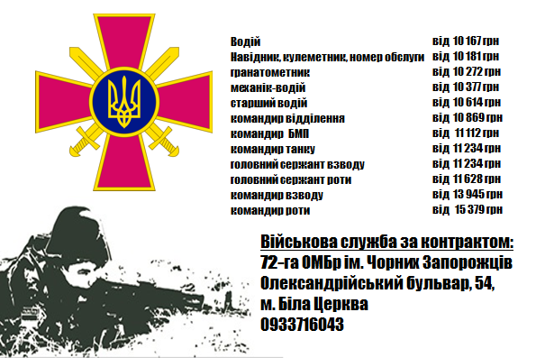

https://www.facebook.com/pg/72.brigade.best/videos/?ref=page_internal

